ASSIGNMENT 02

1. Display entire3 department information
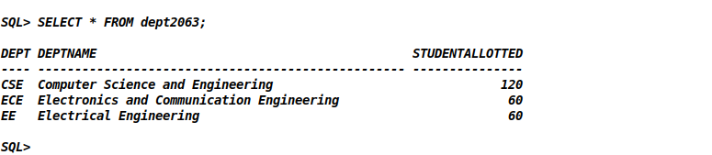
2. Display the dept with allotted student number more than 100.
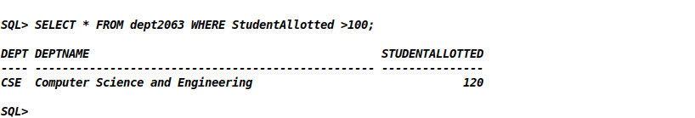
3. Display all students de3tails of CSE
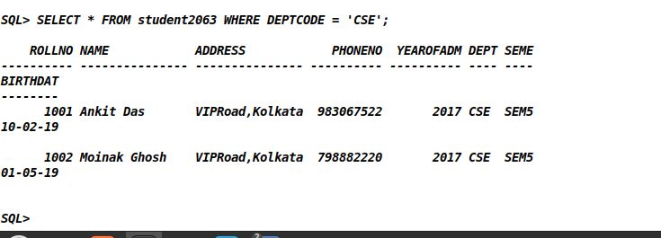
4. Display students name along with department code and semester who admitted in 2018.
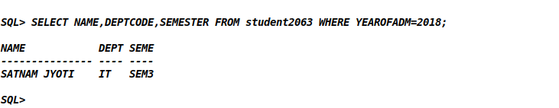

5. Show the name and semester of Cse students who do not have phone numbers.
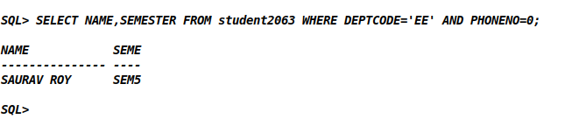

6. Show name and phn num of students whose name start with ‘R’
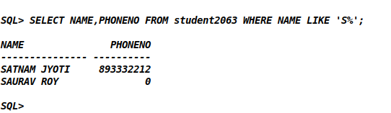

7. Show name and phone numbers of students with surname ‘Singh’.
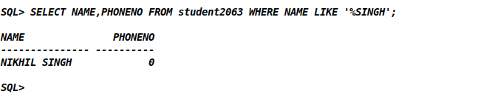

8. Show name,year of admission, deptcode of student with second alphabet of name is ‘A’.
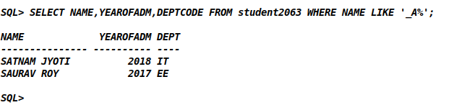

9. Show student details of CSE resident of Kolkata who born before 2000.
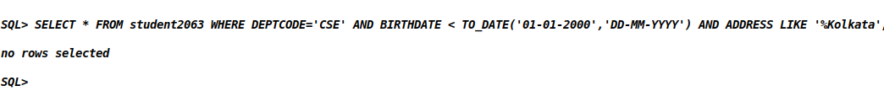
10. Show the details of 2nd year student born in first day of a month
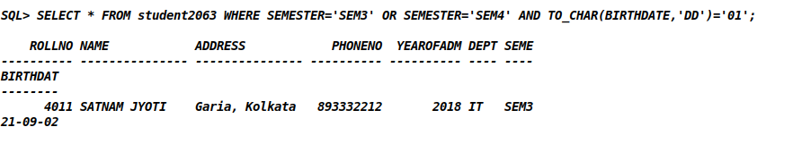

11. Display the students list of IT dept who resides in ‘Kolkata’ and admitted in 2017.
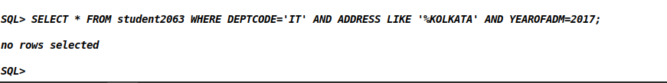
12. Show the phn num, year of admn and birth date of CSE students born in JUNE.
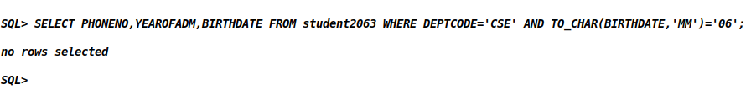

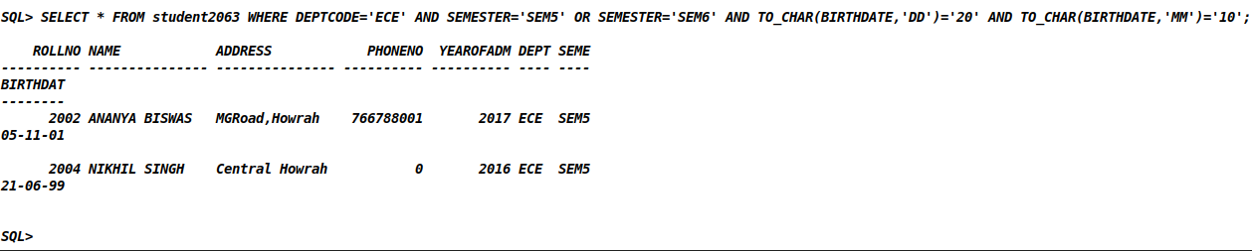
13. Display the list of ECE 3rd year students whose vbirthday is 20th Oct.

14. Show student details who born in either May,June, Sept ort Dec.
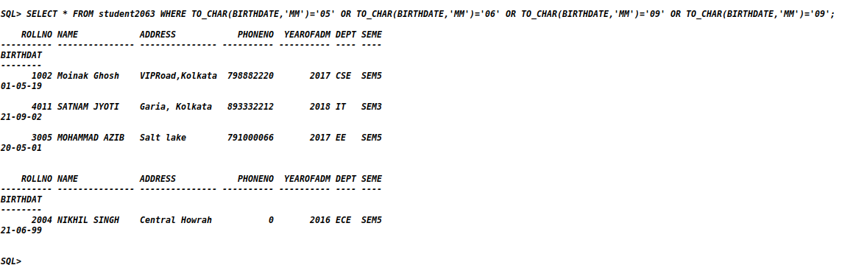

15. Display the students name,department,semester whose age is more than 20year.
